AP10-MM85xxM SFP+ 10Gb/s Active Optical Cable

Features
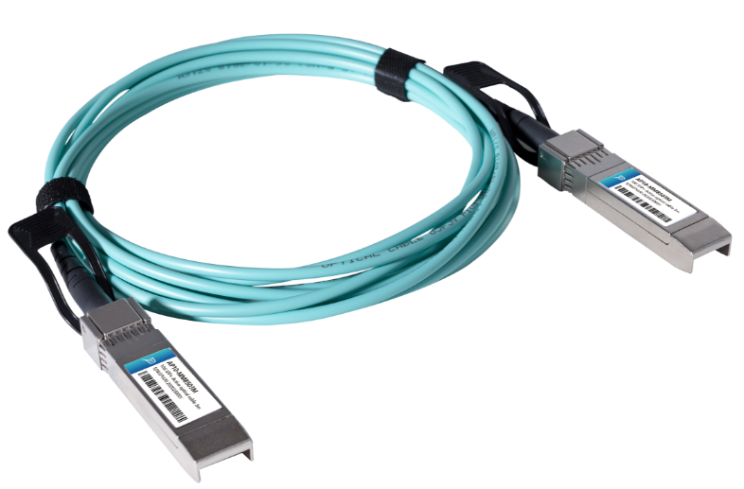
- Up to 300m on OM3 MMF
- Interface compliant to SFF-8431
- Operating case temperature 0°C to 70°C
- Low power consumption <0.35W per end
- Power supply 3.3 V
- RoHS 6 compliant

Applications
- 10 Gigabit Ethernet
- 4G/8G Fiber Channel
- InfiniBand QDR. DDR, SDR
- Servers, switches, storage host card adapters and datacenter

Description
Photonics Valley’s AP10-MM85xxM is active optical cable assemblies with SFP+ connectors. Enjoys low power consumption. It is suitable for short distance and offer a cost-effective way to connect within racks and across adjacent racks. Its length is up to 300 meters on OM3 MMF

Ordering information
AP10-MM8501M | SFP+ Active Optical Cable 1 meter
AP10-MM8502M | SFP+ Active Optical Cable 2 meter
AP10-MM8503M | SFP+ Active Optical Cable 3 meter
AP10-MM8505M | SFP+ Active Optical Cable 5 meter
AP10-MM8510M | SFP+ Active Optical Cable 10 meter
AP10-MM8520M | SFP+ Active Optical Cable 20 meter
AP10-MM8530M | SFP+ Active Optical Cable 30 meter

Absolute Maximum Ratings

The operation in excess of any absolute maximum ratings might cause permanent damage to this module.

Parameter | Symbol | Min | Max | Unit | Note
Storage Temperature | Ts | -20 | 85 | ℃
Relative Humidity(non-condensing) | Rh | 0 | 85 | %
Operating Case Temperature | Ta | 0 | 70 | ℃
Supply Voltage | VCC | -0.3 | 3.6 | V
Input Voltage | Vin | -0.3 | Vcc+0.3 | V

Recommended Operating Conditions

Parameter | Symbol | Min | Typical | Max | Unit
Operating Case Temperature | Tc | 0 |  | 70 | ℃
Power Supply Voltage | Vcc | 3.13 | 3.3 | 3.47 | V
Power Consumption (per end) |  | -0.3 |  | 0.35 | W
Bit Rate | BR |  | 10.3125 |  | Gbps
Rate Tolerance |  | -100 |  | +100 | ppm

Electrical Specifications

Parameter | Symbol | Min | Typical | Max | Unit
Differential input  impedance | Zin | 90 | 100 | 110 | ohm
Differential Output  impedance | Zout | 90 | 100 | 110 | ohm
Differential input  voltage amplitude | ΔVin | 100 |  | 1800 | mVp-p
Differential output  voltage amplitude | ΔVout | 400 |  | 800 | mVp-p
Bit Error Rate | BR |  |  | E-12
Input Logic Level High | VIH | 2.0 |  | VCC | V
Input Logic Level Low | VIL | 0 |  | 0.8 | V

Optical Characteristics

All parameters are specified under the recommended operating conditions with PRBS31 data pattern unless otherwise specified.

Parameter | Symbol | Min | Typical | Max | Unit
Transmitter
Center Wavelength | λC | 840 | 850 | 860 | nm
Average optical Power | PAVE | -6 |  |  | dBm
Rise/Fall Time | Tr/Tf |  |  | 50 | ps
Extinction Ratio | ER | 3.5 |  |  | dB
Relative Intensity Noise | R_{in} |  |  | -128 | dB/Hz
Optical Return Loss  Tolerance | T_{OL} |  |  | 12 | dB
Transmitter Reflectance | RT |  |  | -12 | dB
Receiver
Center Wavelength | λC | 840 | 850 | 860 | nm
Overload, each lane | Povl | -1 |  |  | dBm
Receiver Sensitivity  in OMA | Rsen |  |  | -11 | dBm

Mechanical Dimensions

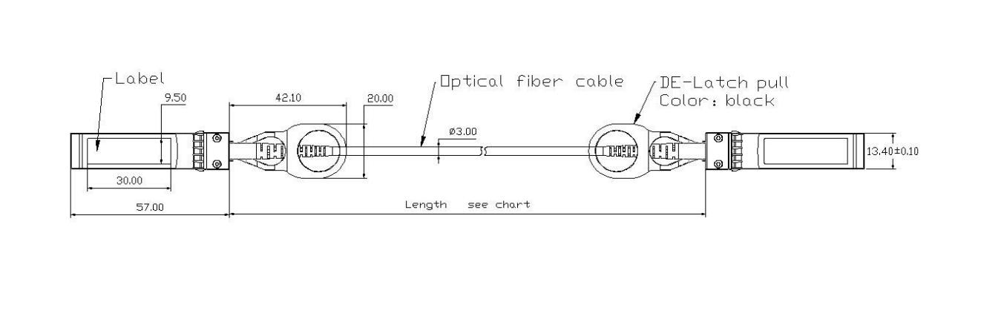

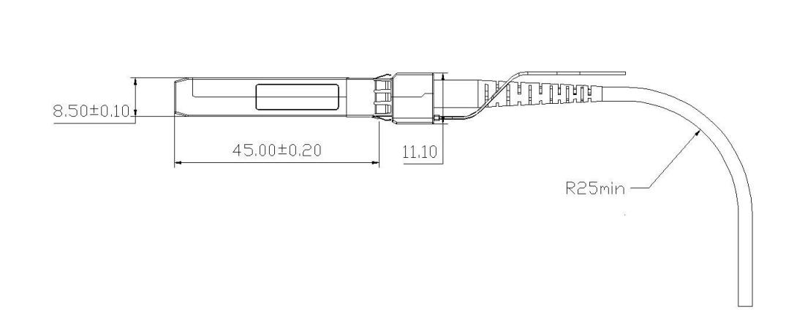

Regulatory Compliance

Feature | Reference | Performance
Electrostatic discharge（ESD） | MIL-STD-883 | Compatible with standards
Electromagnetic Interference (EMI) | FCC Part 15 Class B EN 55022 Class B (CISPR 22A) | Compatible with standards
Laser Eye Safety | FDA 21CFR 1040.10, 1040.11 IEC/EN 60825-1, 2 | Class 1 laser product
ROHS | 2002/95/EC | Compatible with standards
EMC | EN61000-3 | Compatible with standards

Appendix A. Document Revision

Version No. | Date | Description
1.0 | 2019-3-1 | Preliminary datasheet

