AP28-MM85xxM
SFP28 25Gb/s Active Optical Cable

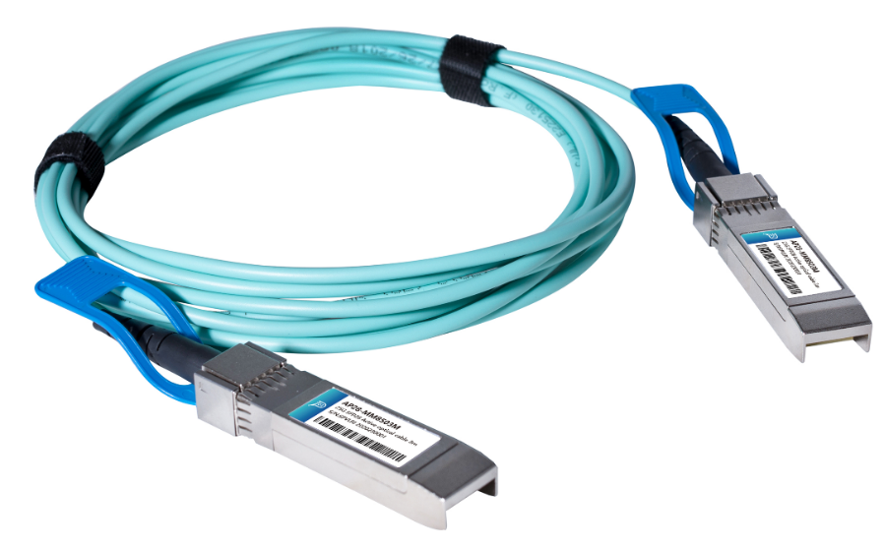
Features
- Up to 70m over OM3 and 100m over OM4
- Interface compliant to SFF-8431 and SFF-8472
- Operating case temperature 0°C to 70°C
- Power supply 3.3 V
- RoHS 6 compliant

Applications
- 25 Gigabit Ethernet
- InfiniBand QDR. DDR, SDR
- Servers, switches, storage host card adapters and datacenter

Description

Photonics Valley’s AP28-MM85xxM is active optical cable assemblies with SFP28 hot pluggable connectors. Enjoys low power consumption. It is suitable for short distance and offer a cost-effective way to connect within racks and across adjacent racks. Its length

is up to 70m over OM3 100m and over OM4.
Ordering information
AP28-MM8501M | 25GBase SFP28 Active Optical Cable 1 meter
AP28-MM8502M | 25GBase SFP28 Active Optical Cable 2 meter
AP28-MM8503M | 25GBase SFP28 Active Optical Cable 3 meter
AP28-MM8505M | 25GBase SFP28 Active Optical Cable 5 meter
AP28-MM8510M | 25GBase SFP28 Active Optical Cable 10 meter
AP28-MM8520M | 25GBase SFP28 Active Optical Cable 20 meter
AP28-MM8530M | 25GBase SFP28 Active Optical Cable 30 meter

Absolute Maximum Ratings

The operation in excess of any absolute maximum ratings might cause permanent damage to this module.

Parameter | Symbol | Min | Max | Unit | Note
Storage Temperature | Ts | -20 | 85 | ℃
Relative Humidity(non-condensing) | RH | 0 | 85 | %
Operating Case Temperature | Tc | 0 | 70 | ℃
Supply Voltage | Vcc | -0.3 | 3.6 | V

Recommended Operating Conditions

Parameter | Symbol | Min | Typical | Max | Unit
Operating Case Temperature | Tc | 0 |  | 70 | ℃
Power Supply Voltage | Vcc | 3.13 | 3.3 | 3.47 | V
Supply current | Icc |  | 300 |  | mA
Bit Rate | BR |  | 25.78 |  | Gbps

Optical Characteristics

Parameter | Symbol | Min | Typical | Max | Unit | Notes
Transmitter
Center Wavelength | λC | 840 | 850 | 860 | nm
Extinction Ratio | ER | 2.0 |  |  | dB
Transmit Enable Voltage | V_{EN} |  |  | 0.8 | V
Transmit Disable Voltage | V_{D} | 2.0 |  |  | V
Average Launch Power | P_{AVG} | -7.5 | -1 | +2.5 | dBm
Input Differential Impedance | Z_{in} | 90 | 100 | 110 | ohm
Differential Data Input Swing | V_{in} PP | 300 |  | 1100 | mV
Receiver
Center Wavelength | λC | 840 | 850 | 860 | nm
Receiver Overload | P_{inMax} | 2.5 |  |  | dBm
Bit Error Rate | BER |  |  | 5E-5 | dBm
Differential Data Output Swing | V_{out} pp | 500 |  | 800 | mV
Output Differential Impedance | Z_{out} | 90 | 100 | 110 | ohm
LOS Fault | V_{OH} | 2.4 |  |  | V
LOS Normal | V_{OL} |  |  | 0.4 | V

Notes: All parameters are specified under the recommended operating conditions with PRBS31 data pattern unless otherwise specified.

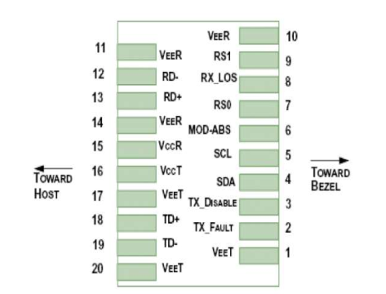
IN Description
Pin | Symbol | Name/Description | NOTE
1 | VEET | Transmitter Ground (Common with Receiver Ground) | 1
2 | TFAULT | Transmitter Fault. | 2
3 | TDIS | Transmitter Disable. Laser output disabled on high or open. | 3
4 | SDA | 2-wire Serial Interface Data Line | 4
5 | SCL | 2-wire Serial Interface Clock Line | 4
6 | MOD_ABS | Module Absent. Grounded within the module | 4
7 | RS0 | Rate Select 0, internal pull down | 5
8 | LOS | Loss of Signal indication. Logic 0 indicates normal operation. | 6
9 | RS1 | Rate Select 1, internal pull down | 5
10 | VEER | Receiver Ground (Common with Transmitter Ground) | 1
11 | VEER | Receiver Ground (Common with Transmitter Ground) | 1
12 | RD- | Receiver Inverted DATA out. AC Coupled
13 | RD+ | Receiver Non-inverted DATA out. AC Coupled
14 | VEER | Receiver Ground (Common with Transmitter Ground) | 1
15 | VCCR | Receiver Power Supply
16 | VCCT | Transmitter Power Supply
17 | VEET | Transmitter Ground (Common with Receiver Ground) | 1
18 | TD+ | Transmitter Non-Inverted DATA in. AC Coupled.
19 | TD- | Transmitter Inverted DATA in. AC Coupled.
20 | VEET | Transmitter Ground (Common with Receiver Ground) | 1

Notes:
  - Circuit ground is internally isolated from chassis ground.
  - TFAULT is an open collector/drain output, which should be pulled up with a 4.7k – 10k Ohms resistor on the host board if intended for use. Pull up voltage should be between 2.0V to Vcc + 0.3V.A high output indicates a transmitter fault caused by either the TX bias current or the TX output power exceeding the preset alarm thresholds. A low output indicates normal operation. In the low state, the output is pulled to <0.8V.
  - Laser output disabled on TDIS>2.0V or open, enabled on TDIS<0.8V.
  - Should be pulled up with 4.7kΩ- 10kΩ host board to a voltage between 2.0V and 3.6V. MOD_ABS pull line low to indicate module is plugged in.
  - Rate select can also be set through the 2-wire bus in accordance with SFF-8472. Rx Rate Select is set at Bit 3, Byte 110, Address A2h. Tx Rate Select is set at Bit 3, Byte 118, Address A2h.
  - LOS is open collector output. It should be pulled up with 4.7kΩ – 10kΩ on host board to a voltage between 2.0V and 3.6V. Logic 0 indicates normal operation; logic 1 indicates loss of signal.

Mechanical Dimensions

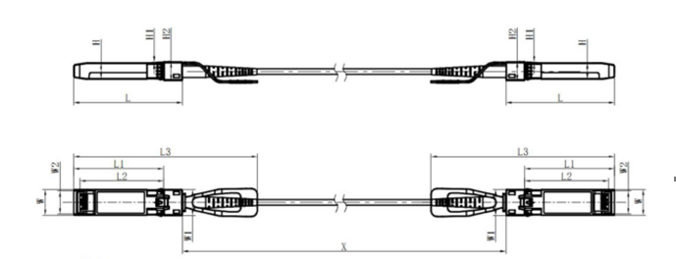

Regulatory Compliance
Feature | Reference | Performance
Electrostatic discharge（ESD） | IEC/EN 61000-4-2 | Compatible with standards
Electromagnetic Interference (EMI) | FCC Part 15 Class B EN 55022 Class B (CISPR 22A) | Compatible with standards
Laser Eye Safety | FDA 21CFR 1040.10, 1040.11 IEC/EN 60825-1, 2 | Class 1 laser product
Component Recognition | IEC/EN 60950, UL | Compatible with standards
ROHS | 2002/95/EC | Compatible with standards
EMC | EN61000-3 | Compatible with standards

Appendix A. Document Revision

Version No. | Date | Description
1.0 | 2018-3-1 | Preliminary datasheet

