AP40-MM85xxM
QSFP40 40Gb/s Active Optical Cable

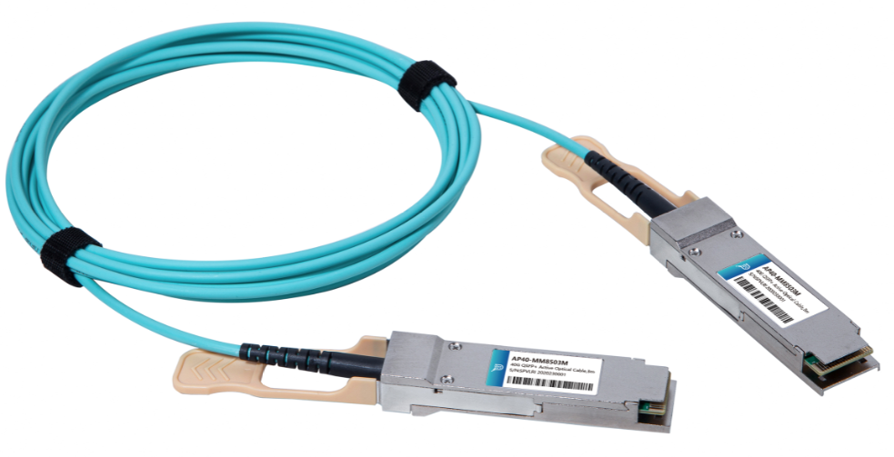
Features
- Support 40GBASE-SR4
- Multi rate of up to 40Gbps
- Distance up to 100m
- Compliant with SFF-8436
- Single power supply 3.3V
- Operating case temp 0°C to +70 °C
- RoHS compliant

Applications
- 40GBASE-SR4
- InfiniBand QDR. DDR, SDR
- Datacom and Telecom switch and router backplane

Description

Photonics Valley’s AP40-MM85xxM is active optical cable assemblies with QSFP+ hot pluggable connectors. Enjoys low power consumption. It is suitable for short distance and offer a cost-effective way to connect within racks and across adjacent racks. Its length is up to 100m over OM3.
Ordering information
AP40-MM8501M | 40GBase QSFP+ Active Optical Cable 1 meter
AP40-MM8502M | 40GBase QSFP+ Active Optical Cable 2 meter
AP40-MM8503M | 40GBase QSFP+ Active Optical Cable 3 meter
AP40-MM8505M | 40GBase QSFP+ Active Optical Cable 5 meter
AP40-MM8510M | 40GBase QSFP+ Active Optical Cable 10 meter
AP40-MM8520M | 40GBase QSFP+ Active Optical Cable 20 meter
AP40-MM8530M | 40GBase QSFP+ Active Optical Cable 30 meter

Absolute Maximum Ratings

The operation in excess of any absolute maximum ratings might cause permanent damage to this module.

Parameter | Symbol | Min | Typical | Max | Unit
Supply Voltage | V_{cc} | -0.5 | - | +3.6 | V
Storage Temperature | T_{s} | -10 | - | +70 | °C
Operating Humidity | R_{H} | +5 | - | +85 | %

Recommended Operating Conditions

Parameter | Symbol | Min | Typical | Max | Unit
Operating Case Temperature | T_{C} | 0 | - | +70 | °C
Power Supply Voltage | Vcc | 3.14 | 3.3 | 3.47 | V
Power dissipation | P_{d} | - | - | 1.5 | w | 1
Bit rate | BR | 1.25 | 10.3125 | - | Gbps

Electrical Characteristics

Parameter |  | Symbol | Min. | Typ. | Max. | Units | Notes
ModSelL | Module Select | VOL | 0 | - | 0.8 | V
 | Module Unselect | VOH | 2.5 | - | VCC | V
LPMode | Low Power Mode | VIL | 0 | - | 0.8 | V
 | Normal Operation | VIH | 2.5 | - | V_{CC}+0.3 | V
Reset L | Reset | VIL | 0 | - | 0.8 | V
 | Normal Operation | VIH | 2.5 | - | V_{CC}+0.3 | V
ModPrsL | Normal Operation | VOL | 0 | - | 0.4 | V
IntL | Interrupt | VOL | 0 | - | 0.4 | V
 | Normal Operation | VoH | 2.4 | - | VCC | V
Electrical transmitter Characteristics
Differential Date Input Swing |  | Vout | 200 | - | 1600 | mV
Output Differential Impedance |  | Z_{D} | 90 | 100 | 110 | ohm
Electrical Receiver Characteristics
Differential Data Output Swing |  | Vin,P-P | 350 | - | 800 | mV_{PP}
Bit Error Rate |  | BER |  |  | 5E-5 |  | 1
Input Differential Impedance |  | ZIN | 90 | 100 | 110 | ohm

Notes: All parameters are specified under the recommended operating conditions with PRBS2^31-1@10.3125Gbps data pattern unless otherwise specified.

PIN Description

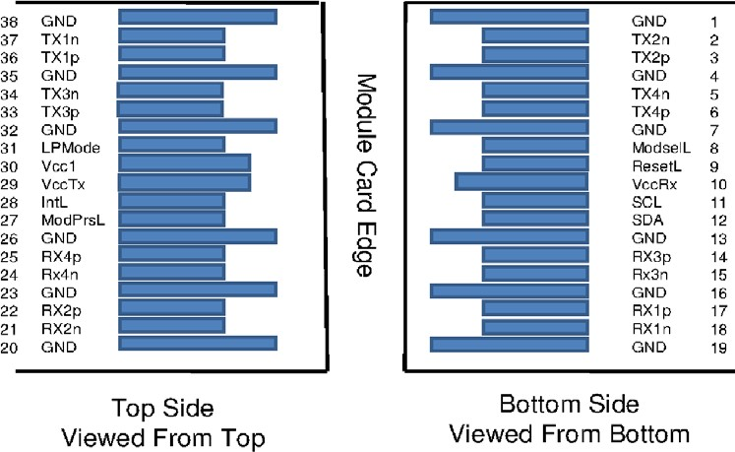

Pin Function Definition

Pin | Symbol | Name/Description | Notes
1 | GND | Ground | 1
2 | Tx2n | Transmitter Inverted Data Input
3 | Tx2p | Transmitter Non-Inverted Data Input
4 | GND | Ground | 1
5 | Tx4n | Transmitter Inverted Data Input
6 | Tx4p | Transmitter Non-Inverted Data Input
7 | GND | Ground | 1
8 | ModSelL | Module Select
9 | ResetL | Module Reset
10 | Vcc Rx | +3.3V Power Supply Receiver
11 | SCL | 2-wire serial interface clock
12 | SDA | 2-wire serial interface data
13 | GND | Ground | 1
14 | Rx3p | Receiver Non-Inverted Data Output
15 | Rx3n | Receiver Inverted Data Output
16 | GND | Ground | 1
17 | Rx1p | Receiver Non-Inverted Data Output
18 | Rx1n | Receiver Inverted Data Output
19 | GND | Ground | 1
20 | GND | Ground | 1
21 | Rx2n | Receiver Inverted Data Output
22 | Rx2p | Receiver Non-Inverted Data Output
23 | GND | Ground | 1
24 | Rx4n | Receiver Inverted Data Output
25 | Rx4p | Receiver Non-Inverted Data Output
26 | GND | Ground | 1
27 | ModPrsL | Module Present
28 | IntL | Interrupt
29 | Vcc Tx | +3.3V Power supply transmitter
30 | Vcc1 | +3.3V Power supply
31 | LPMode | Low Power Mode
32 | GND | Ground | 1
33 | Tx3p | Transmitter Non-Inverted Data Input
34 | Tx3n | Transmitter Inverted Data Input
35 | GND | Ground | 1
36 | Tx1p | Transmitter Non-Inverted Data Input
37 | Tx1n | Transmitter Inverted Data Input
38 | GND | Ground | 1

Notes: All Circuit ground is internally isolated from chassis ground.

Mechanical Design

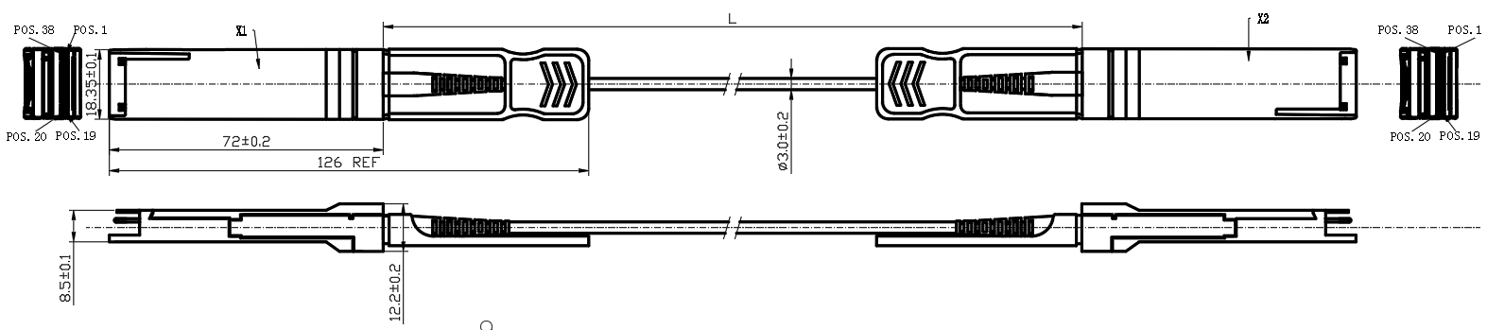

Cable Length & Tolerance

Cable Length/ m | Tolerance /cm
＜1.0 | +10/-0
1.0≤L≤4.5 | +15/-0
4.5＜L≤14.5 | +30/-0
＞14.5 | +2 L/-0

Regulatory Compliance
Feature | Reference | Performance
Electrostatic discharge（ESD） | IEC/EN 61000-4-2 | Compatible with standards
Electromagnetic Interference (EMI) | FCC Part 15 Class B EN 55022 Class B (CISPR 22A) | Compatible with standards
Laser Eye Safety | FDA 21CFR 1040.10, 1040.11 IEC/EN 60825-1, 2 | Class 1 laser product
Component Recognition | IEC/EN 60950, UL | Compatible with standards
ROHS | 2002/95/EC | Compatible with standards
EMC | EN61000-3 | Compatible with standards

Appendix A. Document Revision

Version No. | Date | Description
1.0 | 2018-3-1 | Preliminary datasheet

