AP4X-MM85xxM
QSFP40 40Gb/s to 4SFP+ Breakout Active Optical Cable

Features
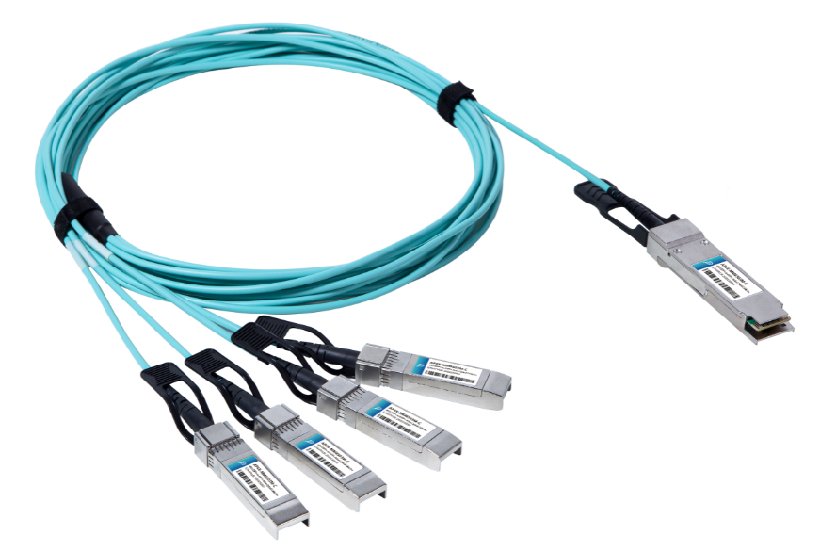
- Support 40GBASE-SR4
- Distance up to 100m
- Multi rate of up to 40Gbps
- QSFP+ interface compliant with SFF-8436
- SFP+ interface compliant with SFF-8431 and SFF- 8472
- Single power supply 3.3V
- Operating case temp 0°C to +70 °C
- RoHS compliant

Applications
- 40GBASE-SR4
- InfiniBand QDR. DDR, SDR
- Datacom and Telecom switch and router backplane

Description

Photonics Valley’s AP4X-MM85xxM is active optical cable assemblies with QSFP+ to 4 SFP+ hot pluggable connectors. Enjoys low power consumption. It is suitable for short distance and offer a cost-effective way to connect within racks and across adjacent racks. Its length is up to 100m over OM3.
Ordering information
AP4X-MM8501M | 40GBase QSFP+ to 4 SFP+ Breakout Active Optical Cable 1 meter
AP4X-MM8502M | 40GBase QSFP+ to 4 SFP+ Breakout Active Optical Cable 2 meter
AP4X-MM8503M | 40GBase QSFP+ to 4 SFP+ Breakout Active Optical Cable 3 meter
AP4X-MM8505M | 40GBase QSFP+ to 4 SFP+ Breakout Active Optical Cable 5 meter
AP4X-MM8510M | 40GBase QSFP+ to 4 SFP+ Breakout Active Optical Cable 10 meter
AP4X-MM8520M | 40GBase QSFP+ to 4 SFP+ Breakout Active Optical Cable 20 meter
AP4X-MM8530M | 40GBase QSFP+ to 4 SFP+ Breakout Active Optical Cable 30 meter

Absolute Maximum Ratings

The operation in excess of any absolute maximum ratings might cause permanent damage to this module.

Parameter | Symbol | Min | Typical | Max | Unit
Supply Voltage | V_{cc} | -0.5 | +3.3 | +3.6 | V
Storage Temperature | T_{s} | -10 | - | +70 | °C
Operating Humidity | R_{H} | +5 | - | +85 | %

Recommended Operating Conditions

Parameter | Symbol | Min | Typical | Max | Unit
Operating Case Temperature | T_{C} | 0 |  | +70 | ℃
Supply Voltage | V_{CC} | +3.14 | +3.3 | +3.47 | V
Supply current (QSFP+) | I_{CC} |  |  | 450 | mA | 1
Supply current (SFP+ per lane) | I_{CC} |  |  | 150 | mA
Bit Rate Per lane | BR |  | 10.3125 |  | Gbps

Electrical and Optical characteristics

Parameter | Symbol | Min | Typical | Max | Unit
Transmitter
Centre Wavelength | λC | 830 | 850 | 870 | nm
RMS spectral width | P_{m} |  |  | 0.45 | nm
Average launch power, each lane | P_{AVG} | -6.0 | - | +2.4 | dBm
Extinction Ratio | ER | 3.0 | - | - | dB
Input differential swing | V_{in} PP | 200 | - | 1600 | mV
Input differential impedance | Z_{in} | 90 | 100 | 110 | ohm
Receiver
Centre Wavelength | λC | 830 | 850 | 870 | nm
Bit Error Rate | BER |  |  | E-12
Differential Data Output Swing | V_{out} PP | 400 |  | 1000 | mV
Output Differential Impedance | Z_{out} | 90 | 100 | 110 | ohm

Notes: All parameters are specified under the recommended operating conditions with PRBS2^31-1@10.3125Gbps data pattern unless otherwise specified.

QSFP+ PIN Description

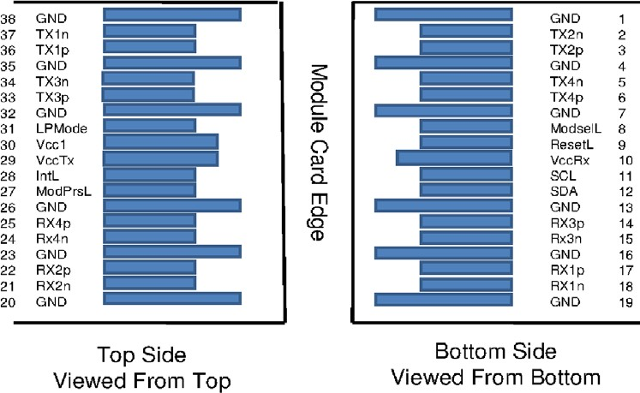

Pin Function Definition

Pin | Symbol | Name/Description | Notes
1 | GND | Ground | 1
2 | Tx2n | Transmitter Inverted Data Input
3 | Tx2p | Transmitter Non-Inverted Data Input
4 | GND | Ground | 1
5 | Tx4n | Transmitter Inverted Data Input
6 | Tx4p | Transmitter Non-Inverted Data Input
7 | GND | Ground | 1
8 | ModSelL | Module Select
9 | ResetL | Module Reset
10 | Vcc Rx | +3.3V Power Supply Receiver
11 | SCL | 2-wire serial interface clock
12 | SDA | 2-wire serial interface data
13 | GND | Ground | 1
14 | Rx3p | Receiver Non-Inverted Data Output
15 | Rx3n | Receiver Inverted Data Output
16 | GND | Ground | 1
17 | Rx1p | Receiver Non-Inverted Data Output
18 | Rx1n | Receiver Inverted Data Output
19 | GND | Ground | 1
20 | GND | Ground | 1
21 | Rx2n | Receiver Inverted Data Output
22 | Rx2p | Receiver Non-Inverted Data Output
23 | GND | Ground | 1
24 | Rx4n | Receiver Inverted Data Output
25 | Rx4p | Receiver Non-Inverted Data Output
26 | GND | Ground | 1
27 | ModPrsL | Module Present
28 | IntL | Interrupt
29 | Vcc Tx | +3.3V Power supply transmitter
30 | Vcc1 | +3.3V Power supply
31 | LPMode | Low Power Mode
32 | GND | Ground | 1
33 | Tx3p | Transmitter Non-Inverted Data Input
34 | Tx3n | Transmitter Inverted Data Input
35 | GND | Ground | 1
36 | Tx1p | Transmitter Non-Inverted Data Input
37 | Tx1n | Transmitter Inverted Data Input
38 | GND | Ground | 1

Notes: All Circuit ground is internally isolated from chassis ground.

SFP+ Pin Function Definition

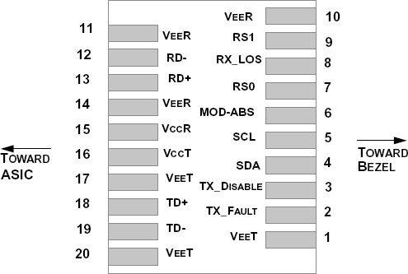

Pin | Symbol | Description
1 | VEET | Module Transmitter Ground
2 | TX_FAULT | Module Transmitter Fault
3 | TX_DISABLE | Transmitter Disable; Turns off transmitter laser output
4 | SDA | 2-Wire Serial Interface Data Line (MOD-DEF2)
5 | SCL | 2-Wire Serial Interface Clock (MOD-DEF1)
6 | MOD_ABS | Module Absent, connected to V_{EE}T or V_{EE}R in the module
7 | RS0 | Rate Select 0, optionally controls SFP+ module receiver
8 | RX_LOS | Receiver Loss of Signal Indication (In FC designated as RxLOS and in Ethernet designated as NOT Signal Detect)
9 | RS1 | Rate Select 1, optionally controls SFP+ module transmitter
10 | V_{EE}R | Module Receiver Ground
11 | V_{EE}R | Module Receiver Ground
12 | RD- | Receiver Inverted Data Output
13 | RD+ | Receiver Non-Inverted Data Output
14 | V_{EE}R | Module Receiver Ground
15 | V_{CC}R | Module Receiver 3.3 V Supply
16 | V_{CC}T | Module Transmitter 3.3 V Supply
17 | V_{EE}T | Module Transmitter Ground
18 | TD+ | Transmitter Non-Inverted Data Input
19 | TD- | Transmitter Inverted Data Input
20 | V_{EE}T | Module Transmitter Ground

Mechanical Design

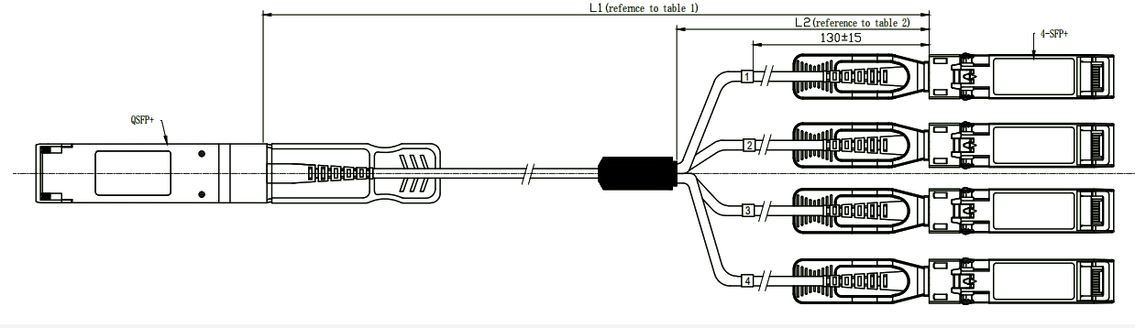

Cable Length & Tolerance

Cable Length/ m | Tolerance /cm
＜1.0 | +10/-0
1.0≤L≤4.5 | +15/-0
4.5＜L≤14.5 | +30/-0
＞14.5 | +2 L/-0

Regulatory Compliance
Feature | Reference | Performance
Electrostatic discharge（ESD） | IEC/EN 61000-4-2 | Compatible with standards
Electromagnetic Interference (EMI) | FCC Part 15 Class B EN 55022 Class B (CISPR 22A) | Compatible with standards
Laser Eye Safety | FDA 21CFR 1040.10, 1040.11 IEC/EN 60825-1, 2 | Class 1 laser product
Component Recognition | IEC/EN 60950, UL | Compatible with standards
ROHS | 2002/95/EC | Compatible with standards
EMC | EN61000-3 | Compatible with standards

Appendix A. Document Revision

Version No. | Date | Description
1.0 | 2019-3-1 | Preliminary datasheet

