AP1H4X-MM85xxM
QSFP28 100Gb/s to 4 SFP28 Active Optical Cable

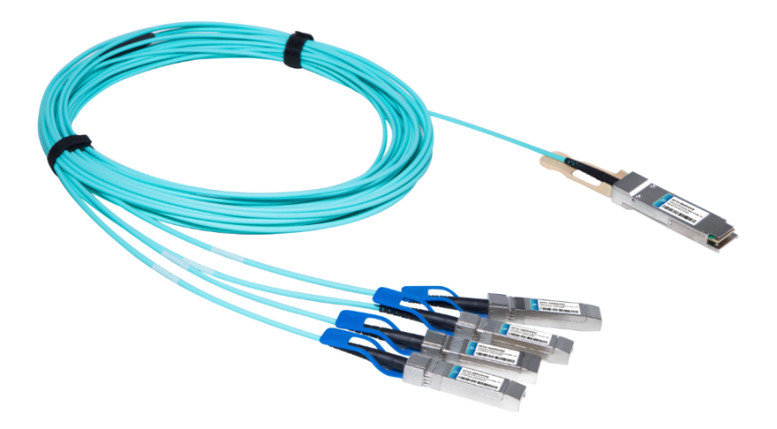
Features
- Support 100GBASE-SR4,InfiniBand EDR
- Multi rate of up to 100Gbps
- QSFP28 interface compliant with SFF-8636
- SFP+ interface compliant with SFF-8431 and SFF- 8472
- Single power supply 3.3V
- Distance up to 50m over MMF
- Operating case temp 0°C to +70 °C
- RoHS compliant

Applications
- 100GBASE-SR4
- InfiniBand QDR, EDR
- Datacom and Telecom switch and router backplane connections

Description

Photonics Valley’s AP1H4X-MM85xxM is active optical cable assemblies with QSFP28 to 4 SFP28 hot pluggable connectors. Enjoys low power consumption. It is suitable for short distance and offer a cost-effective way to connect within racks and across adjacent racks. Its length is up to 100m over OM3.
Ordering information
AP1H4X-MM8501M | 100GBase QSFP28 to 4*25G SFP28 AOC 1 meter
AP1H4X-MM8502M | 100GBase QSFP28 to 4*25G SFP28 AOC 2 meter
AP1H4X-MM8503M | 100GBase QSFP28 to 4*25G SFP28 AOC 3 meter
AP1H4X-MM8505M | 100GBase QSFP28 to 4*25G SFP28 AOC 5 meter
AP1H4X-MM8510M | 100GBase QSFP28 to 4*25G SFP28 AOC 10 meter
AP1H4X-MM8520M | 100GBase QSFP28 to 4*25G SFP28 AOC 20 meter
AP1H4X-MM8530M | 100GBase QSFP28 to 4*25G SFP28 AOC 30 meter

Absolute Maximum Ratings

The operation in excess of any absolute maximum ratings might cause permanent damage to this module.

Parameter | Symbol | Min | Typical | Max | Unit
Supply Voltage | V_{cc3} | -0.5 | - | +3.6 | V
Storage Temperature | T_{S} | -10 | - | +70 | °C
Operating Humidity | R_{H} | +5 | - | +85 | %

Recommended Operating Conditions

Parameter | Symbol | Min | Typical | Max | Unit
Operating Case Temperature | T_{C} | 0 | - | +70 | °C
Power Supply Voltage | V_{cc} | 3.14 | 3.3 | 3.47 | V
Power Dissipation | P_{D} | - | - | 2.5 | W | 1
Bit Rate per lane | BR | 10.3125 | 25.78125 | - | Gbps

Electrical Characteristics of QSFP28

Parameter |  | Symbol | Min. | Typ. | Max. | Units | Notes
ModSelL | Module Select | VOL | 0 | - | 0.8 | V
 | Module Unselect | VOH | 2.5 | - | VCC | V
LPMode | Low Power Mode | VIL | 0 | - | 0.8 | V
 | Normal Operation | VIH | 2.5 | - | V_{CC}+0.3 | V
ResetL | Reset | VIL | 0 | - | 0.8 | V
 | Normal Operation | VIH | 2.5 | - | V_{CC}+0.3 | V
ModPrsL | Normal Operation | VOL | 0 | - | 0.4 | V
IntL | Interrupt | VOL | 0 | - | 0.4 | V
 | Normal Operation | VoH | 2.4 | - | VCC | V
Electrical transmitter Characteristics
Differential Date Input Swing |  | Vin，p-p | 200 | - | 1600 | mV
Output Differential Impedance |  | Zin | 90 | 100 | 110 | ohm
Electrical Receiver Characteristics
Differential Data Output Swing |  | Vout | 200 | - | 800 | mV
Bit Error Rate |  | BER | - | - | 5E-5 | - | 1
Input Differential Impedance |  | ZD | 90 | 100 | 110 | ohm

Notes: All parameters are specified under the recommended operating conditions with PRBS2^31-1@25.78125Gbps data pattern unless otherwise specified.

Electrical Characteristics of SFP28

Parameter |  |  | Symbol |  | Min. | Typ. | Max. | Units |  | Notes
Electrical Transmitter Characteristics
Differential Data Input Swing |  |  | Vin,P-P |  | 200 | - | 1600 |  | mV_{PP}
Input Differential Impedance |  |  | ZIN |  | 90 | 100 | 110 |  | Ohm
Tx_Fault | Normal Operation |  | VOL |  | 0 | - | 0.8 |  | V
 | Transmitter Fault |  | VOH |  | 2.0 | - | VCC |  | V
Tx_Disable | Normal Operation |  | VIL |  | 0 | - | 0.8 |  | V
 | Laser Disable |  | VIH |  | 2.0 | - | V_{CC}+0.3 |  | V
Electrical Receiver Characteristics
Differential Date Output |  |  |  | Vout | 400 | - | 800 | mV
Bit Error Rate |  |  |  | BER | - | - | E-12 | -
Output Differential Impedance |  |  |  | Z_{D} | 90 | 100 | 110 | ohm
Rx_LOS |  | Normal Operation |  | VOL | 0 | - | 0.8 | V
 |  | Lose Signal |  | VoH | 2.0 | - | VCC | V

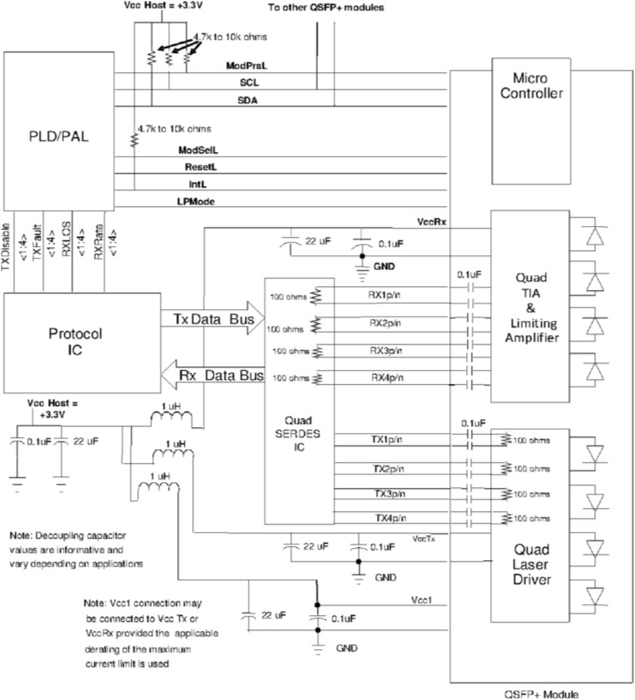
Interface Circuit

PIN Arrangement
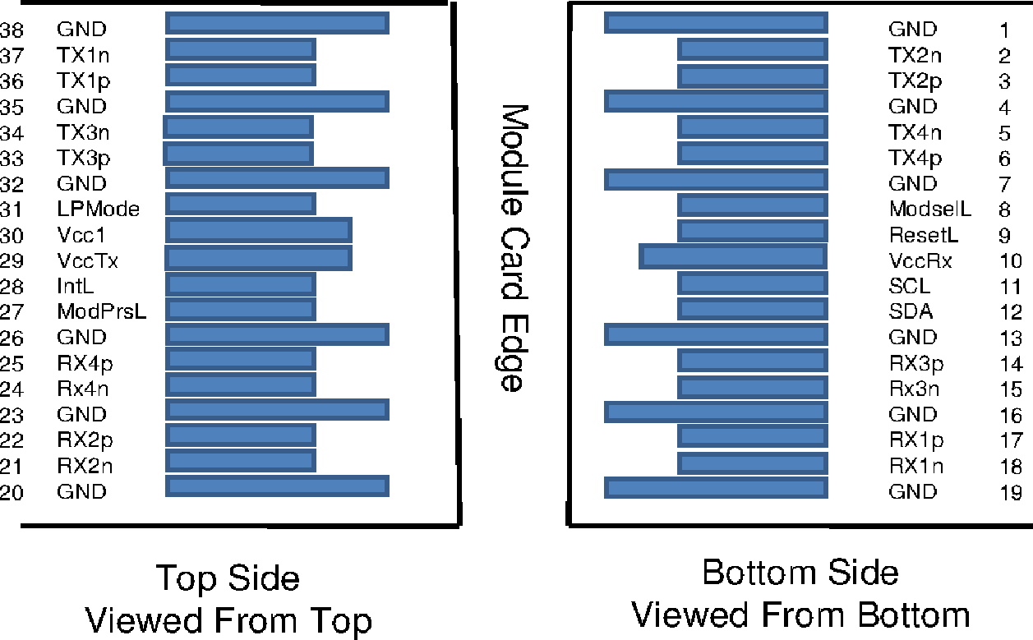

Pin Function Definition for QSFP28
Pin | Symbol | Name/Description | Notes
1 | GND | Ground | 1
2 | Tx2n | Transmitter Inverted Data Input
3 | Tx2p | Transmitter Non-Inverted Data Input
4 | GND | Ground | 1
5 | Tx4n | Transmitter Inverted Data Input
6 | Tx4p | Transmitter Non-Inverted Data Input
7 | GND | Ground | 1
8 | ModSelL | Module Select
9 | ResetL | Module Reset
10 | Vcc Rx | +3.3V Power Supply Receiver
11 | SCL | 2-wire serial interface clock
12 | SDA | 2-wire serial interface data
13 | GND | Ground | 1
14 | Rx3p | Receiver Non-Inverted Data Output
15 | Rx3n | Receiver Inverted Data Output
16 | GND | Ground | 1
17 | Rx1p | Receiver Non-Inverted Data Output
18 | Rx1n | Receiver Inverted Data Output
19 | GND | Ground | 1
20 | GND | Ground | 1
21 | Rx2n | Receiver Inverted Data Output
22 | Rx2p | Receiver Non-Inverted Data Output
23 | GND | Ground | 1
24 | Rx4n | Receiver Inverted Data Output
25 | Rx4p | Receiver Non-Inverted Data Output
26 | GND | Ground | 1
27 | ModPrsL | Module Present
28 | IntL | Interrupt
29 | Vcc Tx | +3.3V Power supply transmitter
30 | Vcc1 | +3.3V Power supply
31 | LPMode | Low Power Mode
32 | GND | Ground | 1
33 | Tx3p | Transmitter Non-Inverted Data Input
34 | Tx3n | Transmitter Inverted Data Input
35 | GND | Ground | 1
36 | Tx1p | Transmitter Non-Inverted Data Input
37 | Tx1n | Transmitter Inverted Data Input
38 | GND | Ground | 1
Notes: All Circuit ground is internally isolated from chassis ground.

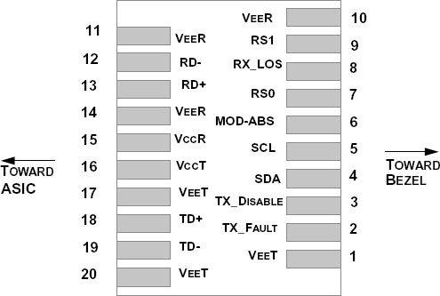

Pin Function Definition for SFP28

Pin | Symbol | Name/Description | Notes
1 | VEET | Module Transmitter Ground | 1
2 | TX_FAULT | Module Transmitter Fault | 2
3 | TX_DISABLE | Transmitter Disable; Turns off transmitter laser output | 3
4 | SDA | 2-Wire Serial Interface Data Line (MOD-DEF2)
5 | SCL | 2-Wire Serial Interface Clock (MOD-DEF1)
6 | MOD_ABS | Module Absent, connected to V_{EE}T or V_{EE}R in the module | 2
7 | RS0 | Rate Select 0, optionally controls SFP+ module receiver | 4
8 | RX_LOS | Receiver Loss of Signal Indication (In FC designated as Rx_LOS and in Ethernet designated as NOT Signal Detect) | 2
9 | RS1 | Rate Select 1, optionally controls SFP+ module transmitter | 4
10 | V_{EE}R | Module Receiver Ground | 1
11 | V_{EE}R | Module Receiver Ground | 1
12 | RD- | Receiver Inverted Data Output
13 | RD+ | Receiver Non-Inverted Data Output
14 | V_{EE}R | Module Receiver Ground | 1
15 | V_{CC}R | Module Receiver 3.3 V Supply
16 | V_{CC}T | Module Transmitter 3.3 V Supply
17 | V_{EE}T | Module Transmitter Ground | 1
18 | TD+ | Transmitter Non-Inverted Data Input
19 | TD- | Transmitter Inverted Data Input
20 | V_{EE}T | Module Transmitter Ground | 1

Note:
- The module ground pins are isolated from the module case.
- The pins shall be pulled up with 4.7K-10Kohms to a voltage between 3.14V and 3.46V on host board.
- The pin is pulled up to VCCT with a 4.7K-10KΩ resistor in the module.
- See SFF-8472 Rev12.2 Table 10-2.

Mechanical Design
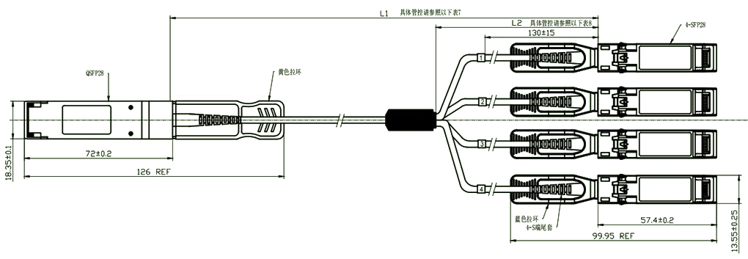

Cable length & Tolerance

Cable Length / m | Tolerance/ cm
≤1.0 | +5/-0
1.0＜L≤4.5 | +15/-0
4.5＜L≤14.5 | +30/-0
＞14.5 | +2%/-0

Breakout Cable Nominal Length

Total Length / m | Breakout Point Measured from SFP28 / m
1 | 0.7
2 | 1.4
3 | 2
≥5 | 3

Regulatory Compliance
Feature | Reference | Performance
Electrostatic discharge（ESD） | IEC/EN 61000-4-2 | Compatible with standards
Electromagnetic Interference (EMI) | FCC Part 15 Class B EN 55022 Class B (CISPR 22A) | Compatible with standards
Laser Eye Safety | FDA 21CFR 1040.10, 1040.11 IEC/EN 60825-1, 2 | Class 1 laser product
Component Recognition | IEC/EN 60950, UL | Compatible with standards
ROHS | 2002/95/EC | Compatible with standards
EMC | EN61000-3 | Compatible with standards

Appendix A. Document Revision

Version No. | Date | Description
1.0 | 2019-3-1 | Preliminary datasheet

