**SP28-DPxMxxWG SFP28 25Gb/s Direct Attached Cable**

# PRODUCT FEATURES

* Up to 25.78125 Gbps data rate
* Up to 7meter transmission
* Hot-pluggable SFP 20PIN footprint
* Compliant with SFF-8402 and SFF-8432
* Temperature Range: 0~ 70 °C
* RoHS Compliant

# APPLICATIONS

* 25G Ethernet

# PRODUCT DESCRIPTION

The SFP28 passive cable assemblies are high performance, cost effective I/O solutions for 25G Ethernet. SFP28 copper cables allow hardware manufactures to achieve high port density, configurability and utilization at a very low cost and reduced power budget

**Ordering Information**

|  |  |
| --- | --- |
| **Part Number** | **Description** |
| SP28-DP1M30WG | 25G SFP28 DAC Passive cable 30AWG 1M |
| SP28-DP2M30WG | 25G SFP28 DAC Passive cable 30AWG 2M |
| SP28-DP3M30WG | 25G SFP28 DAC Passive cable 30AWG 3M |
| SP28-DP5M24WG | 25G SFP28 DAC Passive cable 24AWG 5M |
| SP28-AP7M24WG | 25G SFP28 DAC Active cable 24AWG 7M |

## High Speed Characteristics

|  |  |  |  |  |  |  |
| --- | --- | --- | --- | --- | --- | --- |
| Parameter | Symbol | Min | Typical | Max | Unit | Note |
| Differential Impedance | TDR | 90 | 100 | 110 | Ώ |  |
| Insertion loss | SDD21 | 8 |  | 22.48 | dB | At 12.8906 GHz |
| Differential Return Loss | SDD11  SDD22 | 12.45 |  | See 1 | dB | At 0.05 to 4.1 GHz |
| 3.12 |  | See 2 | dB | At 4.1 to 19 GHz |
| Common-mode to common-mode output return loss | SCC11  SCC22 | 2 |  |  | dB | At 0.2 to 19 GHz |
| Differential to common-mode  return loss | SCD11  SCD22 | 12 |  | See 3 | dB | At 0.01 to 12.89 GHz |
| 10.58 |  | See 4 | At 12.89 to 19 GHz |
| Differential to common Mode  Conversion Loss | SCD21-IL | 10 |  |  | dB | At 0.01 to 12.89 GHz |
|  |  | See 5 | At 12.89 to 15.7 GHz |
| 6.3 |  |  | At 15.7 to 19 GHz |
| Channel Operating Margin | COM | 3 |  |  | dB |  |
| Notes:   1. Reflection Coefficient given by equation SDD11(dB) < 16.5 - 2 × SQRT(f ), with f in GHz 2. Reflection Coefficient given by equation SDD11(dB) < 10.66 - 14 × log10(f/5.5), with f in GHz 3. Reflection Coefficient given by equation SCD11(dB) < 22 - (20/25.78)*f, with f in GHz 4. Reflection Coefficient given by equation SCD11(dB) < 15 - (6/25.78)*f, with f in GHz 5. Reflection Coefficient given by equation SCD21(dB) < 27 - (29/22)*f, with f in GHz | | | | | | |

## SFP28 Pin Function Definition



|  |  |  |  |  |  |  |
| --- | --- | --- | --- | --- | --- | --- |
| **Pin** | | **Logic** | **Symbol** | | **Name/Description** | **Notes** |
| **1** | |  | VeeT | | Transmitter Ground |  |
| **2** | | LV-TTL-O | TX_Fault | | N/A | 1 |
| **3** | | LV-TTL-I | TX_DIS | | Transmitter Disable | 2 |
| **4** | | LV-TTL-I/O | SDA | | Tow Wire Serial Data |  |
| **5** | | LV-TTL-I | SCL | | Tow Wire Serial Clock |  |
| **6** | |  | MOD_DEF0 | | Module present, connect to VeeT |  |
| **7** | | LV-TTL-I | RS0 | | N/A | 1 |
| **8** | | LV-TTL-O | LOS | | LOS of Signal | 2 |
| **9** | | LV-TTL-I | RS1 | | N/A | 1 |
| **10** | |  | VeeR | | Reciever Ground |  |
| **11** | |  | VeeR | | Reciever Ground |  |
| **12** | | CML-O | RD- | | Reciever Data Inverted |  |
| **13** | | CML-O | RD+ | | Reciever Data Non-Inverted |  |
| **14** | |  | VeeR | | Reciever Ground |  |
| **15** | |  | VccR | | Reciever Supply 3.3V |  |
| **16** | |  | VccT | | Transmitter Supply 3.3V |  |
| **17** | |  | VeeT | | Transmitter Ground |  |
|  | **18** | CML-I | TD+ |  | Transmitter Data Non-Inverted |  |
|  | **19** | CML_I | TD- |  | Transmitter Data Inverted |  |
|  | **20** |  | VeeT |  | Transmitter Ground |  |
| **1.** | **Signals not supported in SFP+ Copper pulled-down to VeeT with 30K ohms resistor** | | | | |  |
| **2.** | **Passive cable assemblies do not support** | | | **LOS and TX_DIS** | |  |

**Mechanical Specifications**

The connector is compatible with the SFF-8432 specification.

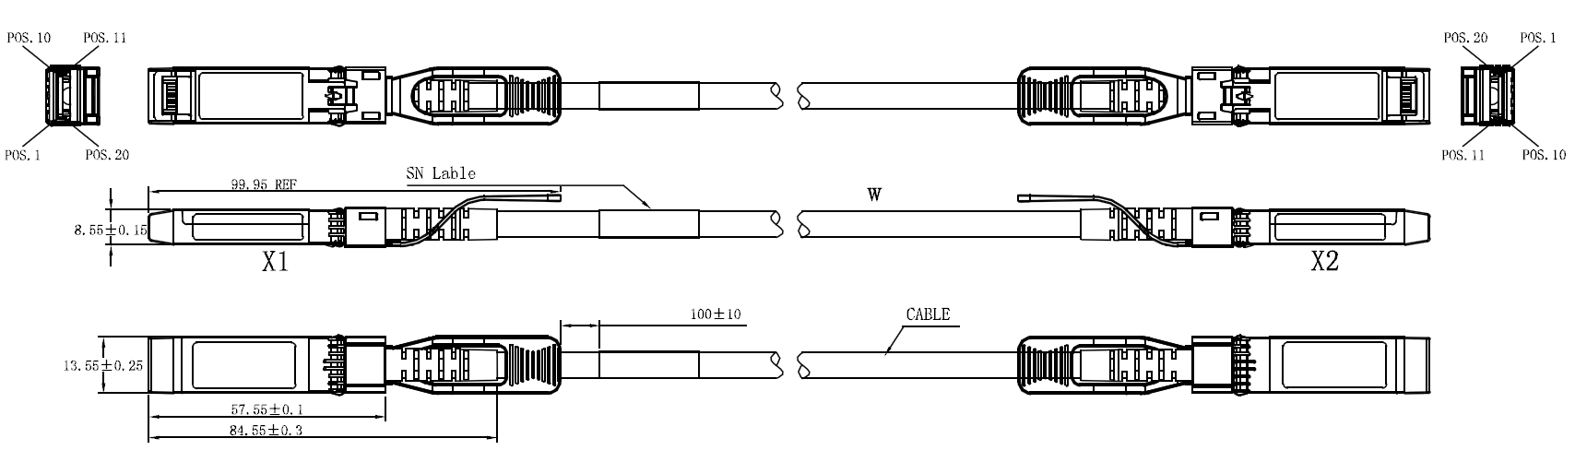

## Regulatory Compliance

|  |  |  |
| --- | --- | --- |
| **Feature** | **Test Method** | **Performance** |
| Electrostatic Discharge (ESD) to the Electrical Pins | MIL-STD-883C Method 3015.7 | Class 1(>2000 Volts) |
| Electromagnetic Interference (EMI) | FCC Class B | Compliant with Standards |
| CENELEC EN55022 Class B |
| CISPR22 ITE Class B |
| RF Immunity (RFI) | IEC61000-4-3 | Typically Show no Measurable Effect from a 10V/m Field Swept from 80 to 1000MHz |
| RoHS Compliance | RoHS Directive 2011/65/EU and it's Amendment Directives 6/6 | RoHS 6/6 compliant |