**QP4X-DPxMxxWG QSFP+ 40Gb/s to 4SFP+ Direct Attached Cable**

# PRODUCT FEATURES

* Up to 40Gbps total bandwidth
* 4 independent duplex channels 10Gbps
* Up to 7meter transmission
* Infiniband QDR
* QSFP+ interface compliant with SFF-8436
* SFP+ interface compliant with SFF-8472
* Temperature Range: 0~ 70 °C
* RoHS compliant

# APPLICATIONS

* 40G Ethernet
* Infiniband QDR
* Networked storage systems
* Hubs, Switches, Routers, Servers

# PRODUCT DESCRIPTION

The QSFP+ passive cable assemblies are high performance, cost effective I/O solutions for 40G Ethernet. QSFP+ copper cables allow hardware manufactures to achieve high port density, configurability and utilization at a very low cost and reduced power budget

# Ordering Information

|  |  |
| --- | --- |
| **Part Number** | **Description** |
| QP40-DP01M30WG | 40G QSFP+ DAC passive cable 1m |
| QP40-DP02M30WG | 40G QSFP+ DAC passive cable 2m |
| QP40-DP03M30WG | 40G QSFP+ DAC passive cable 3m |
| QP40-DP05M26WG | 40G QSFP+ DAC passive cable 5m |
| QP40-DP07M26WG | 40G QSFP+ DAC passive cable 7m |

**General Product Characteristics**

|  |  |
| --- | --- |
| **Q/4SFP+ DAC Specifications** |  |
| Number of Lanes | Tx & Rx |
| Channel Data Rate | 10.3125 Gbps |
| Operating Temperature | 0 to + 70°C |
| Storage Temperature | -40 to + 85°C |
| Supply Voltage | 3.3 V nominal |
| Electrical Interface | 38 pins edge connector(QSFP+)  20 pins edge connector(SFP+) |
| Management Interface | Serial, I2C |

**High Speed Characteristics**

|  |  |  |  |  |  |  |
| --- | --- | --- | --- | --- | --- | --- |
| **Parameter** | **Symbol** | **Min** | **Typ** | **Max** | **Units** | **Notes** |
| Differential Impedance | Zd | 90 | 100 | 110 | ohm |  |
| Differential Input Return Loss | SDDXX | <-12+2* SQRT (f) with f in GHz | | | dB | 0.01~4.1GHz |
| <-6.3+13*  Log10/(f/5.5) with f in GHz | | | dB | 4.1~11.1GHz |
| Common Mode Output Return Loss | SCCXX | < -7+1.6*f with f in GHz | | | dB | 0.01~2.5GHz |
|  |  | -3 | dB | 2.5~11.1GHz |
| Difference Waveform Distortion Penalty | dWDPc |  |  | 6.75 | dB |  |
| VMA Loss | L |  |  | 4.4 | dB |  |
| VMA Loss to Crosstalk Ratio | VCR | 32.5 |  |  | dB |  |

## Pin Function Definition of QSFP+

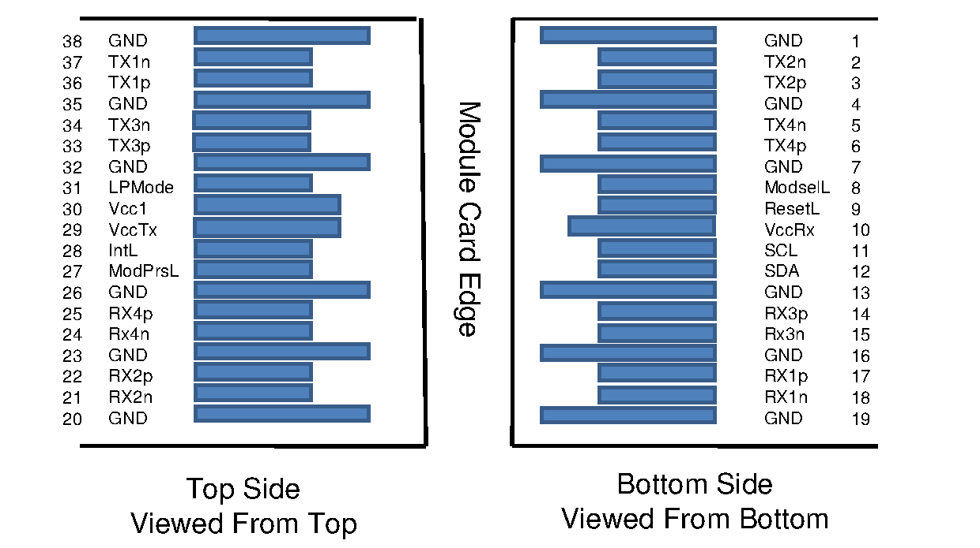

|  |  |  |  |
| --- | --- | --- | --- |
| **Pin** | **Logic** | **Symbol** | **Description** |
| 1 |  | GND | Ground |
| 2 | CML-I | Tx2n | Transmitter Inverted Data Input |
| 3 | CML-I | Tx2p | Transmitter Non-Inverted Data Input |
| 4 |  | GND | Ground |
| 5 | CML-I | Tx4n | Transmitter Inverted Data Input |
| 6 | CML-I | Tx4p | Transmitter Non-Inverted Data Input |
| 7 |  | GND | Ground |
| 8 | LVTTL-I | ModSelL | Module Select |
| 9 | LVTTL-I | ResetL | Module Reset |
| 10 |  | Vcc Rx | +3.3V Power Supply Receiver |
| 11 | LVCMOS-  I/O | SCL | 2-wire serial interface clock |
| 12 | LVCMOS-  I/O | SDA | 2-wire serial interface data |
| 13 |  | GND | Ground |
| 14 | CML-O | Rx3p | Receiver Non-Inverted Data Output |
| 15 | CML-O | Rx3n | Receiver Inverted Data Output |
| 16 |  | GND | Ground |
| 17 | CML-O | Rx1p | Receiver Non-Inverted Data Output |
| 18 | CML-O | Rx1n | Receiver Inverted Data Output |
| 19 |  | GND | Ground |
| 20 |  | GND | Ground |
| 21 | CML-O | Rx2n | Receiver Inverted Data Output |
| 22 | CML-O | Rx2p | Receiver Non-Inverted Data Output |
| 23 |  | GND | Ground |
| 24 | CML-O | Rx4n | Receiver Inverted Data Output |
| 25 | CML-O | Rx4p | Receiver Non-Inverted Data Output |
| 26 |  | GND | Ground |
| 27 | LVTTL-O | ModPrsL | Module Present |
| 28 | LVTTL-O | IntL | Interrupt |
| 29 |  | Vcc Tx | +3.3V Power supply transmitter |
| 30 |  | Vcc1 | +3.3V Power supply |
| 31 | LVTTL-I | LPMode | Low Power Mode |
| 32 |  | GND | Ground |
| 33 | CML-I | Tx3p | Transmitter Non-Inverted Data Input |
| 34 | CML-I | Tx3n | Transmitter Inverted Data Input |
| 35 |  | GND | Ground |
| 36 | CML-I | Tx1p | Transmitter Non-Inverted Data Input |
| 37 | CML-I | Tx1n | Transmitter Inverted Data Input |
| 38 |  | GND | Ground |

## Pin Function Definition of SFP+



|  |  |  |  |
| --- | --- | --- | --- |
| **Pin** | **Logic** | **Symbol** | **Description** |
| 1 |  | VeeT | Module Transmitter Ground |
| 2 | LVTTL-O | Tx_Fault | Module Transmitter Fault |
| 3 | LVTTL-I | Tx_Disable | Transmitter disable; Turns off transmitter laser output |
| 4 | LVTTL-I/O | SDA | 2-wire Serial Interface Data Line (Same as MOD-DEF2 in INF-8074i) |
| 5 | LVTTL-I/O | SCL | 2-wire Serial Interface Clock (Same as MOD-DEF1 in INF-8074i) |
| 6 |  | Mod_ABS | Module Absent, connected to VeeT or VeeR in the module |
| 7 | LVTTL-I | RS0 | Rate Select 0, optionally controls SFP+ module receiver |
| 8 | LVTTL-O | Rx_LOS | Receiver Loss of Signal Indication (In FC designated as Rx_LOS and in Ethernet designated as Signal Detect) |
| 9 | LVTTL-I | RS1 | Rate Select 1, optionally controls SFP+ module transmitter |
| 10 |  | VeeR | Module Receiver Ground |
| 11 |  | VeeR | Module Receiver Ground |
| 12 | CML-O | RD- | Receiver Inverted Data Output |
| 13 | CML-O | RD+ | Receiver Non-Inverted Data Output |
| 14 |  | VeeR | Module Receiver Ground |
| 15 |  | VccR | Module Receiver 3.3 V Supply |
| 16 |  | VccT | Module Transmitter 3.3 V Supply |
| 17 |  | VeeT | Module Transmitter Ground |
| 18 | CML-I | TD+ | Transmitter Non-Inverted Data Input |
| 19 | CML-I | TD- | Transmitter Inverted Data Input |
| 20 |  | VeeT | Module Transmitter Ground |

**Mechanical Specifications**

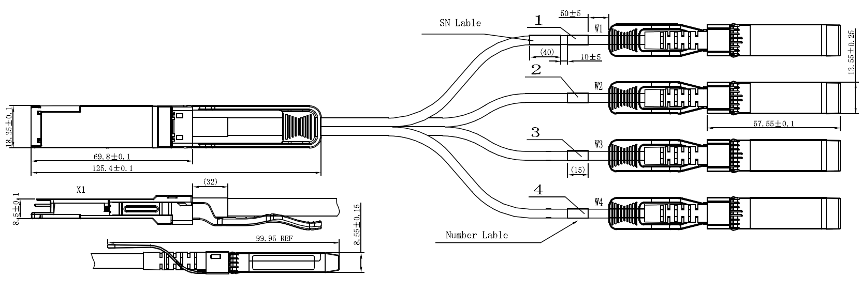

**Regulatory Compliance**

|  |  |  |
| --- | --- | --- |
| **Feature** | **Test Method** | **Performance** |
| Electrostatic Discharge (ESD) to the Electrical Pins | MIL-STD-883C Method 3015.7 | Class 1(>2000 Volts) |
| Electromagnetic Interference (EMI) | FCC Class B | Compliant with Standards |
| CENELEC EN55022 Class B |
| CISPR22 ITE Class B |
| RF Immunity (RFI) | IEC61000-4-3 | Typically Show no Measurable Effect from a 10V/m Field Swept from 80 to 1000MHz |
| RoHS Compliance | RoHS Directive 2011/65/EU and it's Amendment Directives 6/6 | RoHS 6/6 compliant |

**Appendix A. Document Revision**

|  |  |  |
| --- | --- | --- |
| **Version No.** | **Date** | **Description** |
| 1.0 | 2018-3-1 | Preliminary datasheet |