**QP1H-DPxMxxWG QSFP28 100Gb/s Direct Attached Cable**

# PRODUCT FEATURES

* Supports 103.125Gb/s and 112.2Gb/s bit rates
* Up to 28.3125Gbps data rate per channel
* Up to 5m transmission
* Compliant with SFF- 8665 and SFF-8636
* Operating temperature: 0~70℃
* Single 3.3V power supply
* Low total system power solution
* Low total system EMI solution
* RoHS compliant

# APPLICATIONS

* 100G Ethernet
* Data Center networks
* Switches, servers and routers
* Storage area networks

# PRODUCT DESCRIPTION

Photonics Valley’s QSFP28 Direct Attach Cables are compliant with the SFF-8665 specifications. Various choices of wire gauge are available from 30 to 24 AWG with various choices of cable length (up to 5m).

# Ordering Information

|  |  |
| --- | --- |
| **Part Number** | **Description** |
| QP1H-DP1M30WG | 100G QSFP28 DAC passive cable 30AWG 1m |
| QP1H-DP2M30WG | 100G QSFP28 DAC passive cable 30AWG 2m |
| QP1H-DP3M26WG | 100G QSFP28 DAC passive cable 26AWG 3m |
| QP1H-DP5M26WG | 100G QSFP28 DAC passive cable 26AWG 5m |

**General Product Characteristics**

|  |  |
| --- | --- |
| **QSFP+ DAC Specifications** |  |
| Number of Lanes | Tx & Rx |
| Channel Data Rate | 28.3125 Gbps |
| Operating Temperature | 0 to + 70°C |
| Storage Temperature | -40 to + 85°C |
| Supply Voltage | 3.3 V nominal |
| Electrical Interface | 38 pins edge connector |
| Management Interface | Serial, I2C |

**High Speed Characteristics**

|  |  |  |  |  |  |  |
| --- | --- | --- | --- | --- | --- | --- |
| **Parameter** | **Symbol** | **Min** | **Typ** | **Max** | **Units** | **Notes** |
| Differential Impedance | Zd | 90 | 100 | 110 | ohm |  |
| Differential Input Return Loss | SDDXX | <-12+2* SQRT (f) with f in GHz | | | dB | 0.01~4.1GHz |
| <-6.3+13*  Log10/(f/5.5) with f in GHz | | | dB | 4.1~19GHz |
| Common Mode Output Return Loss | SCCXX | < -7+1.6*f with f in GHz | | | dB | 0.01~12.89GHz |
|  |  | -3 | dB | 12.89~19GHz |
| Difference Waveform Distortion Penalty | dWDPc |  |  | 6.75 | dB |  |
| VMA Loss | L |  |  | 4.4 | dB |  |
| VMA Loss to Crosstalk Ratio | VCR | 32.5 |  |  | dB |  |

## Pin Function Definition

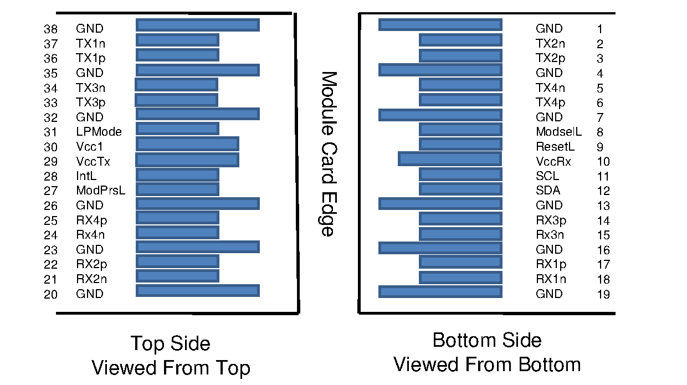

|  |  |  |  |
| --- | --- | --- | --- |
| **Pin** | **Logic** | **Symbol** | **Description** |
| 1 |  | GND | Ground |
| 2 | CML-I | Tx2n | Transmitter Inverted Data Input |
| 3 | CML-I | Tx2p | Transmitter Non-Inverted Data Input |
| 4 |  | GND | Ground |
| 5 | CML-I | Tx4n | Transmitter Inverted Data Input |
| 6 | CML-I | Tx4p | Transmitter Non-Inverted Data Input |
| 7 |  | GND | Ground |
| 8 | LVTTL-I | ModSelL | Module Select |
| 9 | LVTTL-I | ResetL | Module Reset |
| 10 |  | Vcc Rx | +3.3V Power Supply Receiver |
| 11 | LVCMOS-  I/O | SCL | 2-wire serial interface clock |
| 12 | LVCMOS-  I/O | SDA | 2-wire serial interface data |
| 13 |  | GND | Ground |
| 14 | CML-O | Rx3p | Receiver Non-Inverted Data Output |
| 15 | CML-O | Rx3n | Receiver Inverted Data Output |
| 16 |  | GND | Ground |
| 17 | CML-O | Rx1p | Receiver Non-Inverted Data Output |
| 18 | CML-O | Rx1n | Receiver Inverted Data Output |
| 19 |  | GND | Ground |
| 20 |  | GND | Ground |
| 21 | CML-O | Rx2n | Receiver Inverted Data Output |
| 22 | CML-O | Rx2p | Receiver Non-Inverted Data Output |
| 23 |  | GND | Ground |
| 24 | CML-O | Rx4n | Receiver Inverted Data Output |
| 25 | CML-O | Rx4p | Receiver Non-Inverted Data Output |
| 26 |  | GND | Ground |
| 27 | LVTTL-O | ModPrsL | Module Present |
| 28 | LVTTL-O | IntL | Interrupt |
| 29 |  | Vcc Tx | +3.3V Power supply transmitter |
| 30 |  | Vcc1 | +3.3V Power supply |
| 31 | LVTTL-I | LPMode | Low Power Mode |
| 32 |  | GND | Ground |
| 33 | CML-I | Tx3p | Transmitter Non-Inverted Data Input |
| 34 | CML-I | Tx3n | Transmitter Inverted Data Input |
| 35 |  | GND | Ground |
| 36 | CML-I | Tx1p | Transmitter Non-Inverted Data Input |
| 37 | CML-I | Tx1n | Transmitter Inverted Data Input |
| 38 |  | GND | Ground |

**Mechanical Specifications**

The connector is compatible with the SFF-8665 specification.

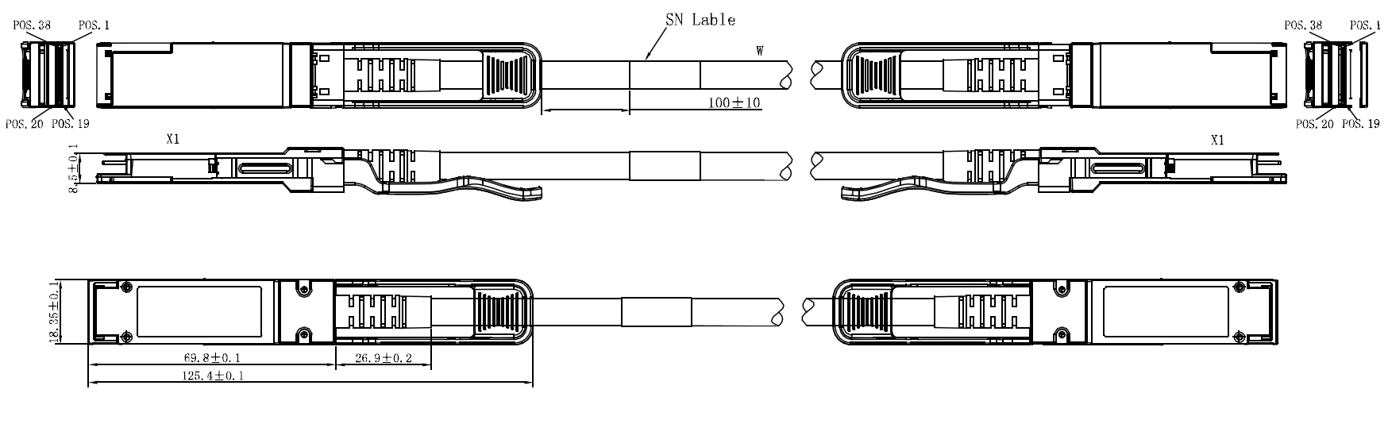

## Regulatory Compliance

|  |  |  |
| --- | --- | --- |
| **Item** | **Test Method** | **Performance** |
| Electrostatic Discharge (ESD) to the Electrical Pins | MIL-STD-883C Method 3015.7 | Class 1(>2000 Volts) |
| Electromagnetic Interference(EMI) | FCC Class B | Compliant with Standards |
| CENELEC EN55022 Class B |
| CISPR22 ITE Class B |
| RF Immunity(RFI) | IEC61000-4-3 | Typically Show no Measurable Effect from a 10V/m Field Swept from 80 to 1000MHz |
| RoHS Compliance | RoHS Directive 2011/65/EU and it's Amendment Directives 6/6 | RoHS 6/6 compliant |

**Appendix A. Document Revision**

|  |  |  |
| --- | --- | --- |
| **Version No.** | **Date** | **Description** |
| 1.0 | 2018-3-1 | Preliminary datasheet |