# QP1H4X-DPxMxxWG QSFP28 100Gb/s to 4 SFP28 Direct Attached Cable

# PRODUCT FEATURES

* Supports aggregate data rates of 100Gbps
* 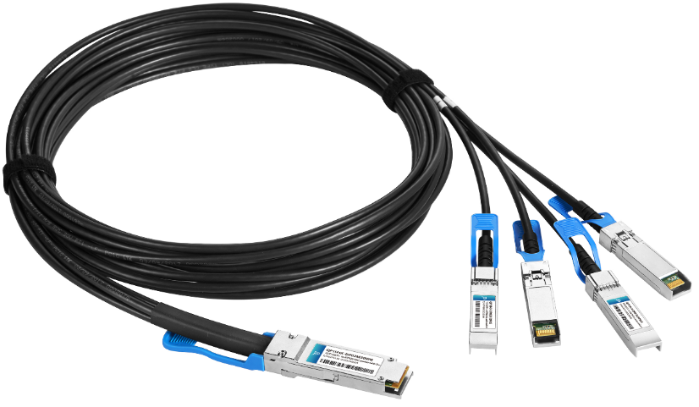Backward compatible with QSFP28 port
* Compatible with IEEE 802.3bj, IEEE 802.3by
* Compliant with InfiniBand EDR
* Compliant with SFF-8665 and SFF-8636
* Operating temperature: 0~70℃
* Single 3.3V power supply
* Lower total system power solution
* Lower total system EMI solution
* RoHS compliant

# APPLICATIONS

* 100G Ethernet and InfiniBand EDR
* Data Center networks
* Switches, servers and routers
* Storage area networks

# PRODUCT DESCRIPTION

Photonics Valley’s QSFP28 to 4 SFP28 passive copper cable assembly feature eight differential copper pairs, providing four data transmission channels at speeds up to 28Gbps per channel, and meets 100G Ethernet,25G Ethernet and InfiniBand Enhanced Data Rate (EDR) requirements. Available in a broad range of wire gages-from 26AWG through 30AWG-this 100G copper cable assembly features low insertion loss。

# Ordering Information

|  |  |
| --- | --- |
| **Part Number** | **Description** |
| QP1H4X-DP1M30WG | 100G QSFP28 to 4 SFP28 DAC passive cable 30AWG 1m |
| QP1H4X-DP2M30WG | 100G QSFP28 to 4 SFP28 DAC passive cable 30AWG 2m |
| QP1H4X-DP3M26WG | 100G QSFP28 to 4 SFP28 DAC passive cable 26AWG 3m |
| QP1H4X-DP5M26WG | 100G QSFP28 to 4 SFP28 DAC passive cable 26AWG 5m |

## High Speed Characteristics

|  |  |  |  |  |  |  |
| --- | --- | --- | --- | --- | --- | --- |
| Parameter | Symbol | Min | Typical | Max | Unit | Note |
| Differential Impedance | TDR | 90 | 100 | 110 | ohm |  |
| Insertion loss | SDD21 | 8 |  | 22.48 | dB | At 12.8906 GHz |
| Differential Return Loss | SDD11  SDD22 | 12.45 |  | See 1 | dB | At 0.05 to 4.1 GHz |
| 3.12 |  | See 2 | dB | At 4.1 to 19 GHz |
| Common-mode to common-mode output return loss | SCC11  SCC22 | 2 |  |  | dB | At 0.2 to 19 GHz |
| Differential to common-mode  return loss | SCD11  SCD22 | 12 |  | See 3 | dB | At 0.01 to 12.89 GHz |
| 10.58 |  | See 4 | At 12.89 to 19 GHz |
| Differential to common Mode  Conversion Loss | SCD21-IL | 10 |  |  | dB | At 0.01 to 12.89 GHz |
|  |  | See 5 | At 12.89 to 15.7 GHz |
| 6.3 |  |  | At 15.7 to 19 GHz |
| Channel Operating Margin | COM | 3 |  |  | dB |  |
| Notes:   1. Reflection Coefficient given by equation SDD11(dB) < 16.5 - 2 × SQRT(f ), with f in GHz 2. Reflection Coefficient given by equation SDD11(dB) < 10.66 - 14 × log10(f/5.5), with f in GHz 3. Reflection Coefficient given by equation SCD11(dB) < 22 - (20/25.78)*f, with f in GHz 4. Reflection Coefficient given by equation SCD11(dB) < 15 - (6/25.78)*f, with f in GHz 5. Reflection Coefficient given by equation SCD21(dB) < 27 - (29/22)*f, with f in GHz | | | | | | |

## Pin Descriptions

SFP28 Pin Function Definition

|  |  |  |  |  |  |  |
| --- | --- | --- | --- | --- | --- | --- |
| Pin | | Logic | Symbol | | Name/Description | Notes |
| 1 | |  | VeeT | | Transmitter Ground |  |
| 2 | | LV-TTL-O | TX Fault | | N/A | 1 |
| 3 | | LV-TTL-I | TX_DIS | | Transmitter Disable | 2 |
| 4 | | LV-TTL-I/O | SDA | | Tow Wire Serial Data |  |
| 5 | | LV-TTL-I | SCL | | Tow Wire Serial Clock |  |
| 6 | |  | MOD_DEF0 | | Module present, connect to VeeT |  |
| 7 | | LV-TTL-I | RS0 | | N/A | 1 |
| 8 | | LV-TTL-O | LOS | | LOS of Signal | 2 |
| 9 | | LV-TTL-I | RS1 | | N/A | 1 |
| 10 | |  | VeeR | | Reciever Ground |  |
| 11 | |  | VeeR | | Reciever Ground |  |
| 12 | | CML-O | RD- | | Reciever Data Inverted |  |
| 13 | | CML-O | RD+ | | Reciever Data Non-Inverted |  |
| 14 | |  | VeeR | | Reciever Ground |  |
| 15 | |  | VccR | | Reciever Supply 3.3V |  |
| 16 | |  | VccT | | Transmitter Supply 3.3V |  |
| 17 | |  | VeeT | | Transmitter Ground |  |
|  | 18 | CML-I | TD+ |  | Transmitter Data Non-Inverted |  |
|  | 19 | CML_I | TD- |  | Transmitter Data Inverted |  |
|  | 20 |  | VeeT |  | Transmitter Ground |  |
| **1.** | **Signals not supported in SFP+ Copper pulled-downto VeeT with 30K ohms resistor** | | | | |  |
| **2.** | **Passive cable assemblies do not support** | | | **LOS and TX_DIS** | |  |



QSFP28 Pin Function Definition

|  |  |  |  |
| --- | --- | --- | --- |
| **Pin** | **Logic** | **Symbol** | **Description** |
| 1 |  | GND | Ground |
|  |  |  |  |
| 2 | CML-I | Tx2n | Transmitter Inverted Data Input |
|  |  |  |  |
| 3 | CML-I | Tx2p | Transmitter Non-Inverted Data Input |
| 4 |  | GND | Ground |
|  |  |  |  |
| 5 | CML-I | Tx4n | Transmitter Inverted Data Input |
|  |  |  |  |
| 6 | CML-I | Tx4p | Transmitter Non-Inverted Data Input |
|  |  |  |  |
| 7 |  | GND | Ground |
|  |  |  |  |
| 8 | LVTTL-I | ModSelL | Module Select |
|  |  |  |  |
| 9 | LVTTL-I | ResetL | Module Reset |
|  |  |  |  |
| 10 |  | Vcc Rx | +3.3V Power Supply Receiver |
|  |  |  |  |
| 11 | LVCMOS- | SCL | 2-wire serial interface clock |
| I/O |
|  |  |  |
|  |  |  |  |
| 12 | LVCMOS- | SDA | 2-wire serial interface data |
| I/O |
|  |  |  |
|  |  |  |  |
| 13 |  | GND | Ground |
|  |  |  |  |
| 14 | CML-O | Rx3p | Receiver Non-Inverted Data Output |
|  |  |  |  |
| 15 | CML-O | Rx3n | Receiver Inverted Data Output |
| 16 |  | GND | Ground |
|  |  |  |  |
| 17 | CML-O | Rx1p | Receiver Non-Inverted Data Output |
|  |  |  |  |
| 18 | CML-O | Rx1n | Receiver Inverted Data Output |
| 19 |  | GND | Ground |
| 20 |  | GND | Ground |
| 21 | CML-O | Rx2n | Receiver Inverted Data Output |
| 22 | CML-O | Rx2p | Receiver Non-Inverted Data Output |
| 23 |  | GND | Ground |
| 24 | CML-O | Rx4n | Receiver Inverted Data Output |
| 25 | CML-O | Rx4p | Receiver Non-Inverted Data Output |
| 26 |  | GND | Ground |
| 27 | LVTTL-O | ModPrsL | Module Present |
| 28 | LVTTL-O | IntL | Interrupt |
| 29 |  | Vcc Tx | +3.3V Power supply transmitter |
| 30 |  | Vcc1 | +3.3V Power supply |
| 31 | LVTTL-I | LPMode | Low Power Mode |
| 32 |  | GND | Ground |
| 33 | CML-I | Tx3p | Transmitter Non-Inverted Data Input |  |  |  |
| 34 | CML-I | Tx3n | Transmitter Inverted Data Input |
| 35 |  | GND | Ground |
|  |  |  |  |
| 36 | CML-I | Tx1p | Transmitter Non-Inverted Data Input |
| 37 | CML-I | Tx1n | Transmitter Inverted Data Input |
| 38 |  | GND | Ground |

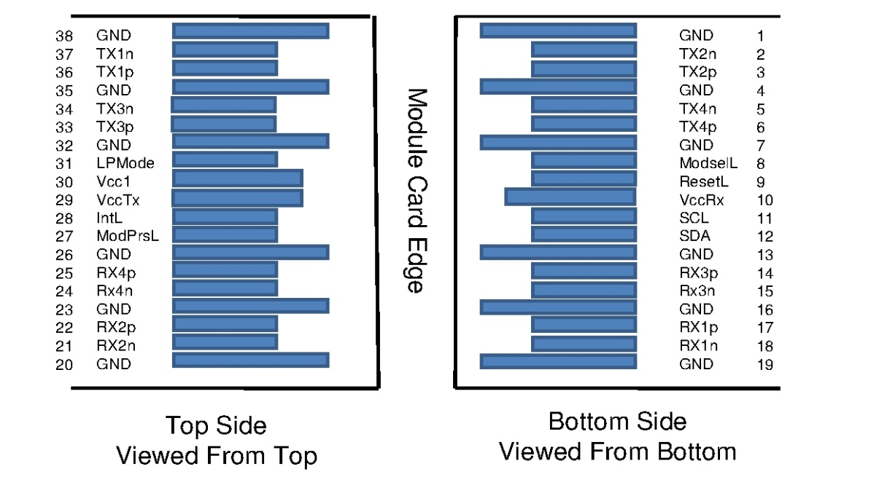

**Mechanical Specifications**

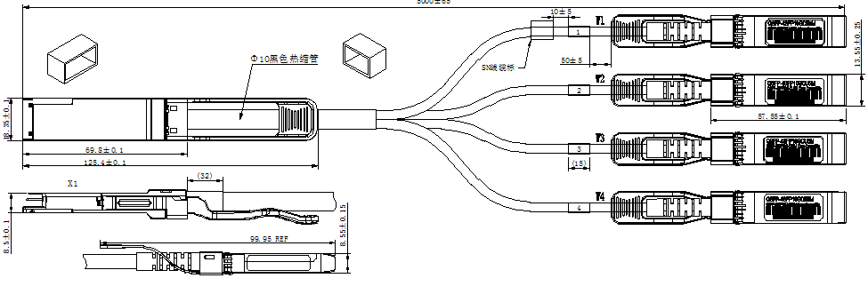

## Regulatory Compliance

|  |  |  |
| --- | --- | --- |
| **Item** | **Test Method** | **Performance** |
| Electrostatic Discharge (ESD) to the Electrical Pins | MIL-STD-883C Method 3015.7 | Class 1(>2000 Volts) |
| Electromagnetic Interference(EMI) | FCC Class B | Compliant with Standards |
| CENELEC EN55022 Class B |
| CISPR22 ITE Class B |
| RF Immunity(RFI) | IEC61000-4-3 | Typically Show no Measurable Effect from a 10V/m Field Swept from 80 to 1000MHz |
| RoHS Compliance | RoHS Directive 2011/65/EU and it's Amendment Directives 6/6 | RoHS 6/6 compliant |

**Appendix A. Document Revision**

|  |  |  |
| --- | --- | --- |
| **Version No.** | **Date** | **Description** |
| 1.0 | 2018-3-1 | Preliminary datasheet |